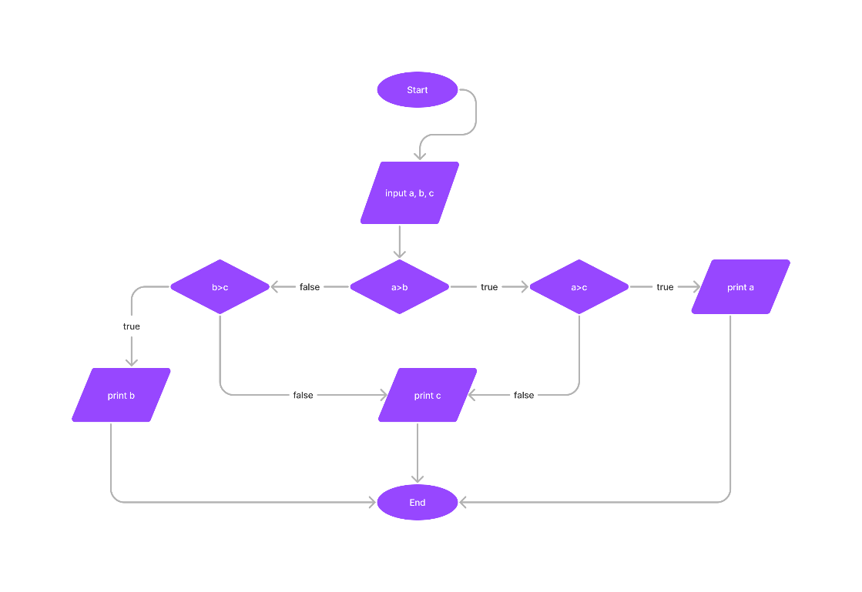begin

input a, b, c

if a > b then

if a > c then

print a

else

print c

endif

else

if b > c

print b

else

print c

endif

endif

end